
ASIC & FPGA Chip Design:
Introduction

Mahdi Shabany

Department of Electrical Engineering Sharif University of technology
Course Code: 25776

Course Outline
- Introduction to IC Design
  - Integrated Circuits (IC) History
  - Digital Design vs. Analog Design
  - ASIC vs. FPGA
  - Design Abstraction and Metrics
  - CMOS as the building block of Digital ASICs
  - Layout
  - Packaging

Course Outline
- Introduction to ASIC/FPGA IC Design
  - Integrated Circuits (IC) History
  - Digital Design vs. Analog Design
  - ASIC vs. FPGA
  - Design Abstraction and Metrics
  - CMOS as the building block of Digital ASICs
  - Layout
  - Packaging

How to go from Idea/Algorithm to the actual hardware

module RippleCarryAdderII (Cin, X, Y, S, Cout);
parameter n = 4; input Cin; input [n-1:0] X, Y; output [n-1:0] S; wire [n-1:0] C;
Full_Adder stage0 (Cin, X[0], Y[0], S[0], C[1]);
Full_Adder stage1 (C[1], X[1], Y[1], S[1], C[2]);
Full_Adder stage2 (C[2], X[2], Y[2], S[2], C[3]);
Full_Adder stage3 (.Cout(Cout), .Cin(C[3]), .x(X[3]), .y(Y[3]), .S(S[3])); endmodule

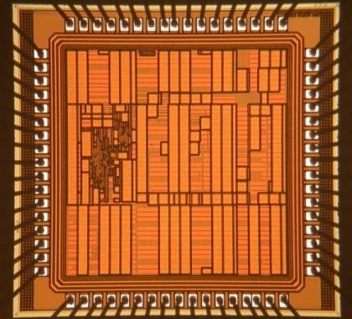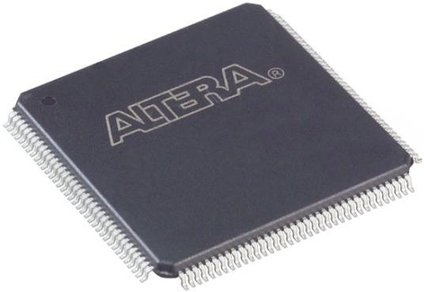

ASIC FPGA

  - Hardware Description Language (HDL) :Verilog
  - Professional Verilog Coding for Synthesis
  - Verification Techniques
  - FPGA Architectures
  - Digital System Design with Xilinx FPGAs
  - ASIC Digital Design Flow (from Verilog to the actual Chip!)
  - Synthesis Algorithms
  - Power Dissipation
  - Power Grid and Clock Design
  - Fixed-point Simulation Methodology
  - Detailed Design Optimization Workshop with ISE (for the fist time!)

Yes
Synthesis
Pre-Layout
Timing Yes
Alanysis Pass?
Post-Layout
Timing Alanysis Pass?
Yes
NO
NO
Test Bench
NO
Simulation Pass?
RTL Coding
Timing Constraints
Logic verification
APR
Standard Cells
Specifications

Tapeout
Back Annotation

- HDL Coding
- Simulation 3. Synthesis
Front-End Back-End
4. Placement & routing
5. Timing Analysis & Verification

  - In this course we learn all the above steps in detail for
    - ASIC Platform
    - FPGA Platform

- Hardware Description Language

➢Verilog Fundamentals
  - Language Fundamentals
  - Modeling Combinational/Sequential Logic Circuits
  - Modeling Finite State Machines

➢Verilog for Verification
  - Verification/Simulation techniques with test‐benches

➢Verilog for synthesis
  - Verilog Styles for Synthesis
  - Architectural techniques for high‐speed designs
    - Parallel proc., pipelining, retiming, …
  - Implementations of common operations
    - Complex multiplication, division, complex norm, CORDIC
  - Fundamentals of fixed‐point realization

PLDs & FPGA Architectures
➢FPGA Technologies
  - SPLDs (PAL and PLA architectures)
  - Commercial CPLD Architectures
  - SRAM/LUT Based FPGAs
  - Anti‐fuse/MUX Based FPGAs
  - Flash Based FPGAs
➢FPGA Architectures
  - Heterogeneous/Homogeneous FPGAs
  - Fine‐grained, coarse‐grained and platform FPGAs
➢FPGA Elements & Design Trade‐offs
  - Logic Cells Common Architectures
  - Programmable Routing Channels Design
  - I/O & Pad architectures
➢Commercial FPGAs
  - Altera (FLEX 10K, Stratix III) , Xilinx (XC4000, Virtex II,4,5), Actel (Act3, Axcelerator)

Advanced Digital System Design with Xilinx FPGAs
- Design Creation
- Synthesize
- Simulation
- Constraints Entry
- Implementation
- Implementation Results Analysis – Timing Analysis
- Implementation Results Analysis – Power Analysis
- Implementation Results Improvement
- Device Configuration and Programming
- Design Debugging

- Core Generator
- CORE Generator Tool
- Intellectual Property (IP) Cores
- CORE Generator Tool files
- Design Flows
- Defining Memory Contents for RAM and ROM
- Defining Coefficient Values in a COE File

- ASIC Design Flow:
➢HDL Coding & Verification
➢Synthesis & Timing Optimization
  - Complete Synopsys Design Complier Design Flow
➢Physical Design
  - Cadence First Encounter
  - Floorplan (Initial floorplan and power planning)
  - Placement (Full‐scale floorplan and clock tree insertion)
  - Routing (power routing & Nanoroute)
  - Timing Closure (Analysis & Optimization of setup and hold time violations)
  - Fill (Filler Cells, Metal Fill, and Verify Geometry)

CAD Tool Algorithms:

➢Synthesis Algorithms
➢Two-level Optimization
➢Multi-level Logic Optimization
➢Technology Mapping

Power Dissipation

Power Dissipation concept
- Dynamic Power
- Static Power
- Challenges

- Power Grid and Clock Design
- Power Distribution Design
  - Introduction
  - IR Drop
  - Ldi/dt Drop
- Decoupling Capacitances
- Clock Considerations
- PLL/DLL Architecture

Prerequisites:

➢Only Digital Logic!
➢All the skills you need will be taught in the course

- Softwares you will learn:
➢Altera Quartus
➢Xilinx ISE
➢Mentor Graphics Modelsim
➢TCL Scripting
➢Synopsys Design Compiler
➢Cadence SOC Encounter

Implementation Platform:
➢Altera DE2 Board
➢Atlys Xilinx Board

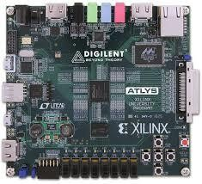
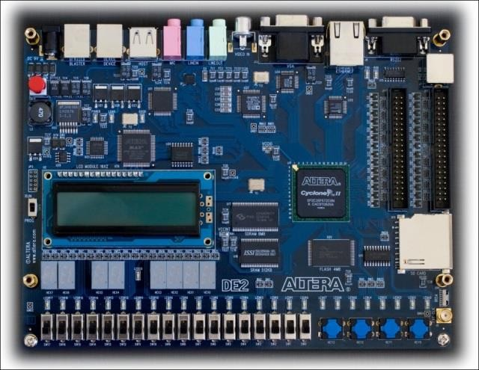
- You will do several practical assignments including Verilog Coding, FPGA implementation and testing based on the DE2 and Atlys Boards

Assignments & Labs (12)

➢4 implementation assignments on DE2 Board (8 Marks)
➢6 Implementation assignments on Atlys boards (12 Marks)
➢2 Paper Assignments (4 marks)
- 1 comprehensive project from A to Z (5 marks)

Soft deadlines: 20% daily penalty for the late submissions

Section | Quantity | Value each | Value
Assignments | 12 | 2 | 24
Project | 1 | 6 | 6
Midterm | 1 | 30 | 30
Final Exam | 1 | 40 | 40

Total:
100

If both the midterm and final marks are less than 50%, the total mark is calculated only based on the exams and assignments will not be taken into account.

HDL:
➢Thomas & Moorby, The Verilog Hardware Description Language, 3rd ed, Kluwer Academic.
➢Introduction to Logic Synthesis using Verilog HDL, Robert Reese, Mitchell Thornton, 2006.
➢Advanced FPGA Design, Architecture, Implementation, and Optimization, Steve Kilts, 2007.

IC Design Flow:
➢Course Lecture notes, 2014
➢Digital IC Design Flow, provided by the instructor, 2014

Course Outline

Course Outline
- Introduction to ASIC/FPGA IC Design
  - Integrated Circuits (IC) History
  - Digital Design vs. Analog Design
  - ASIC vs. FPGA
  - Design Abstraction and Metrics
  - CMOS as the building block of Digital ASICs
  - Layout
  - Packaging

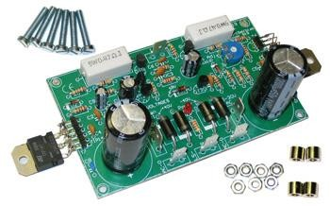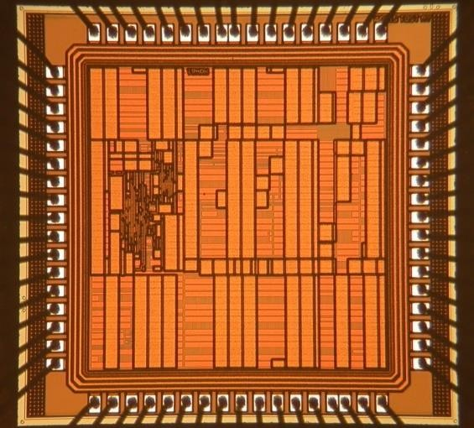

Discrete Circuits
➢Limited applications
➢Power hungry
➢Large area
➢Moderate speed
Integrated Circuits
➢Many applications
➢Low power
➢Small area
➢High speed

1940 1945 1947 1951 1955 1957 1958 1959 1961 1962 1968 1970 1971
 Ohl built the PN Junction: 1940 Shockley Lab was established: 1945
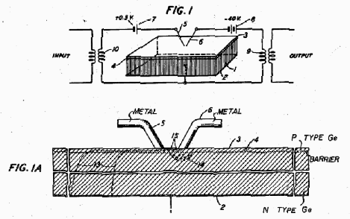Brattain and Bardeen invented the first transistor (US Patent 2524035): 1947

A picture of the filed patent

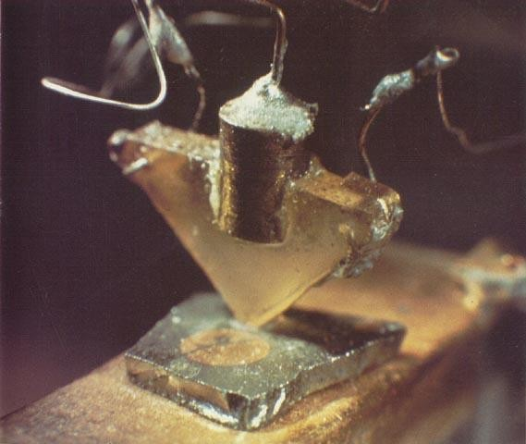


1940 1945 1947 1951 1955 1957 1958 1959 1961 1962 1968 1970 1971

- 1951: Shockley invented the first junction transistor for mass production
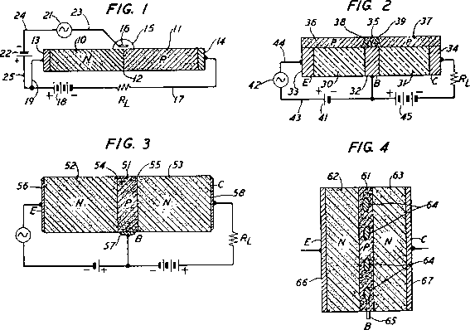➢(US Patent 2623105)

A picture of the filed patent
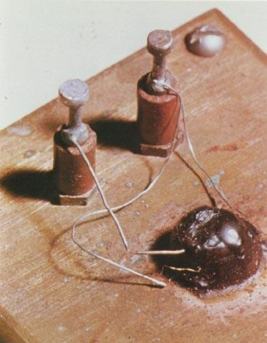


1940 1945 1947 1951 1955 1957 1958 1959 1961 1962 1968 1970 1971

پیوست
Shockley

به آزمایشگاه
Noyce

:1955

Hoerni

با کمک
Fairchild

را به هدف تاسیس
Shockley

آزمایشگاه
Noyce

:1957

ترک کرد
Gorden Moore و

ابداع کرد و به این
تکنیکی را برای افشاندن ناخالصی ها بر روی Si
Hoerni

:1958

بسازد
SiO2

ترتیب توانست یک ترانزیستور مسطح با کمک عایق

اولین مدار مجتمع را با استفاده از ترانزیستورهای مسطح ساخت
Noyce

:1959


1940 1945 1947 1951 1955 1957 1958 1959 1961 1962 1968 1970 1971

کار می کرد ایده مدار مجتمع یک
Texas Instrument (TI)

که در
Jack Kilby

:1959

پارچه را مطرح کرد. در این طرح قطعات به وسیله سیم های لحیم شده به یکدیگر متصل

(U.S Patent (

به عنوان مقاومت استفاده می شد
می شدند و از دیودهای PN

)3,138,473

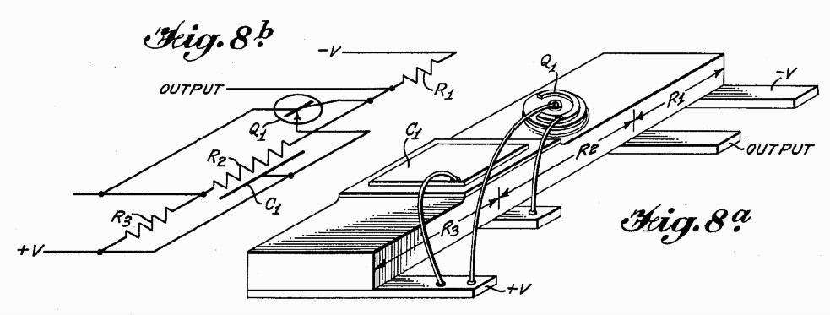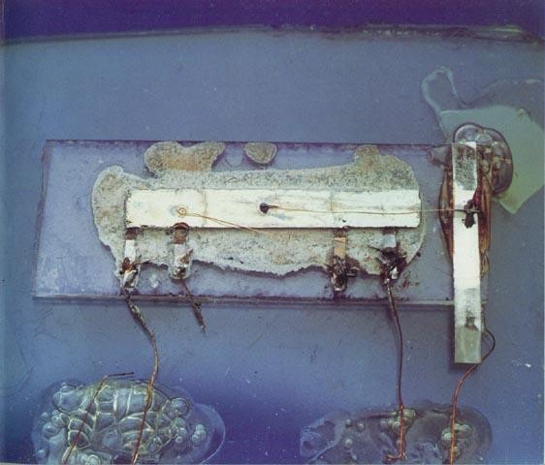

A picture of the filed patent

)50$

(هر کدام
منطقی را تولید انبوه کردند
اولین IC
Fairchild و
TI :1961

شانزده بیتی ساخته شد
Ripple Carry Adder

:1962


Fairchild bipolar RTL Flip-Flop RCA 16-transistor MOSFET IC
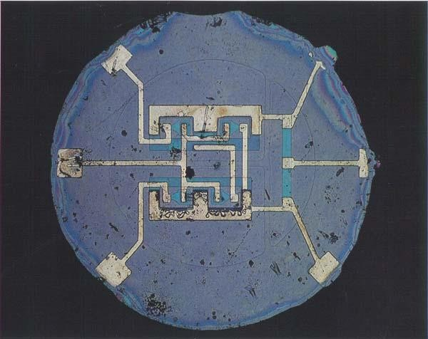
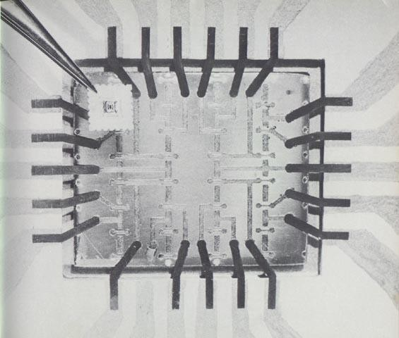


:1968 Noyce و Moore موسسه Fairchild را رها کرده و Intel را پایه گذاری کردند
کرد تولید را Static RAMs 256-bit , Fairchild :1970

را فروخت
Dynamic RAMs 1-K bit , Intel :1970

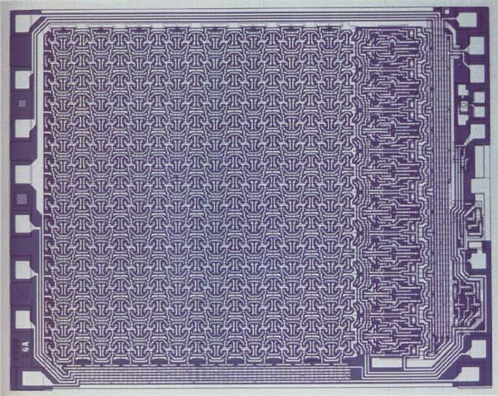
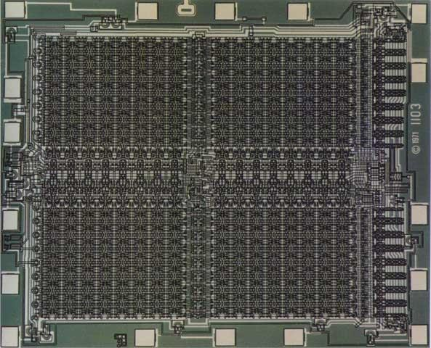
Fairchild 4100 256-bit SRAM Intel 1103 1K-bit DRAM

1940 1945 1947 1951 1955 1957 1958 1959 1961 1962 1968 1970 1971

را تولید کرد
4004 ,
Intel

:1971

اولین کامپیوتر قابل برنامه ریزی چند منظوره برای شرکت ماشین حساب ژاپنی

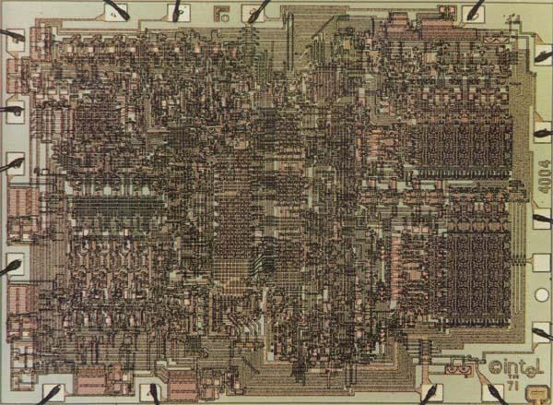



1971 ……………………………………………………………………………………… 2010

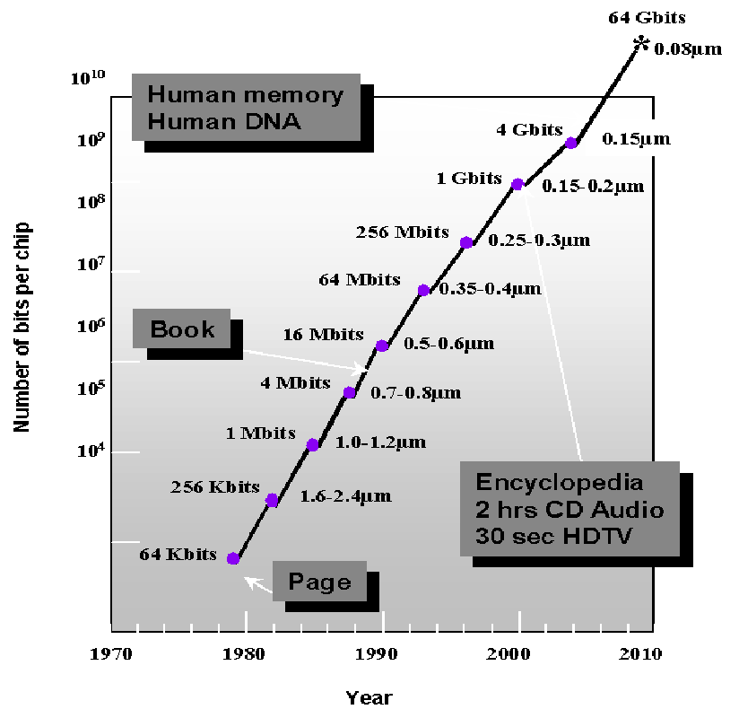
K
1 Billion Transistors
Projected
Pentium® III Pentium® II
i486
Pentium® Pro
Pentium®
i386 80286
8086
1,000,000
100,000

10,000
1,000

100

10
1
1975 1980 1985 1990 1995 2000 2005 2010
Source: Intel
Number of Transistors doubled every 18 months!
(Moore’s Law)
Scaling still continues…

1971 ………………………………………………..……………………… 2015

Amazingly visionary – million transistors/chip barrier was crossed in the 1980’s.
  - 2300 transistors, 1 MHz clock (Intel 4004) - 1971
  - 16 Million transistors (Ultra Sparc III)
  - 42 Million, 2 GHz clock (Intel P4) - 2001
10 gates
1000 gates
10,000 gates
> 10k gates
SSI:
MSI: LSI: VLSI:
Integration Levels
  - 140 Million transistor (HP PA-8500)

Early Designs Advanced Designs
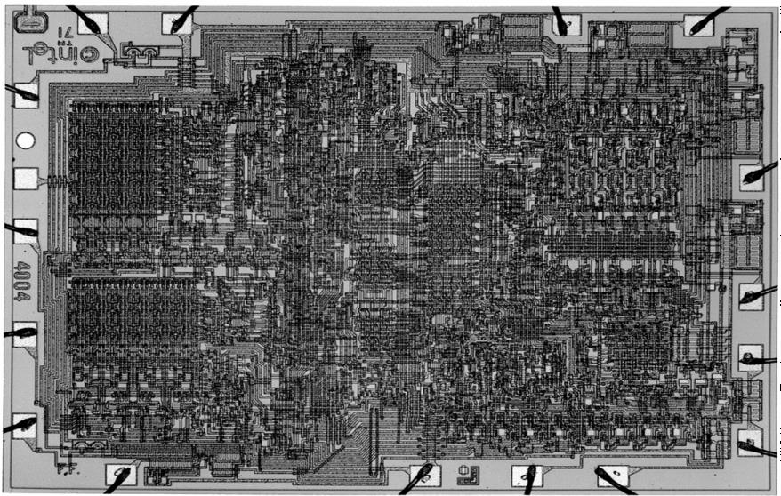
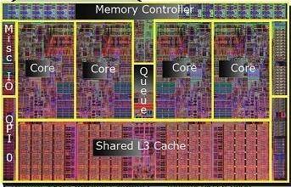
(1971) (2017)

- 1000 Transistors (1 MHz)
- Process: 10um
- Fully Handcrafted
- Manual Layout
- Individually Optimized
- Intel Corei7 -7700K(~ 4.2 GHz)
- Process: 14nm
- Fully Automated
- Automated Layout
- Hierarchical Design

Digital Very Large Scale Integration (VLSI) (Not Analog!)

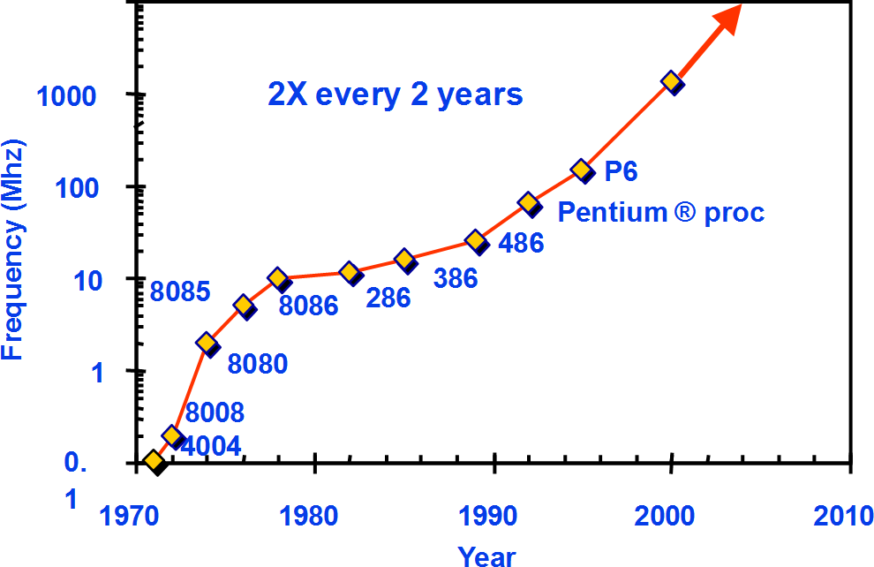
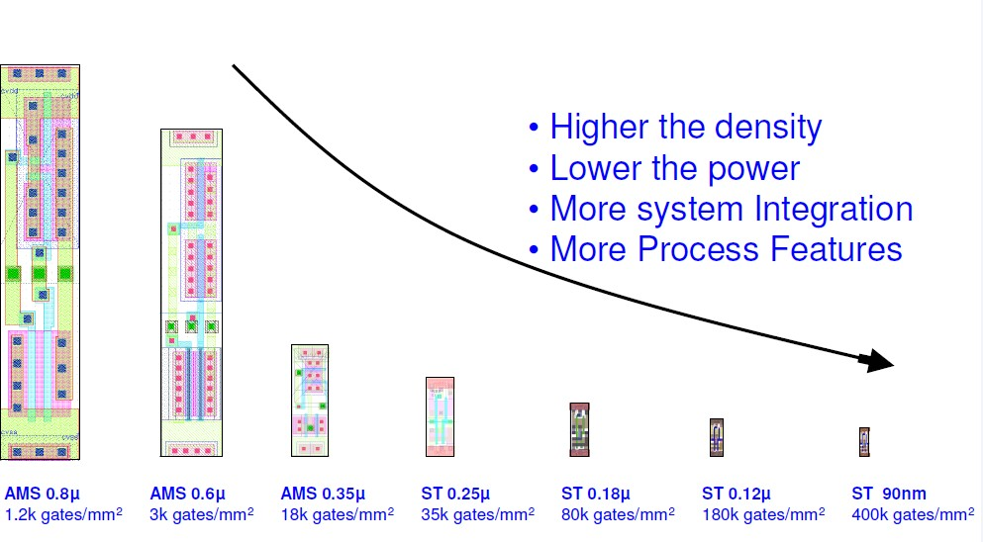
up frequency doubles every 2 years
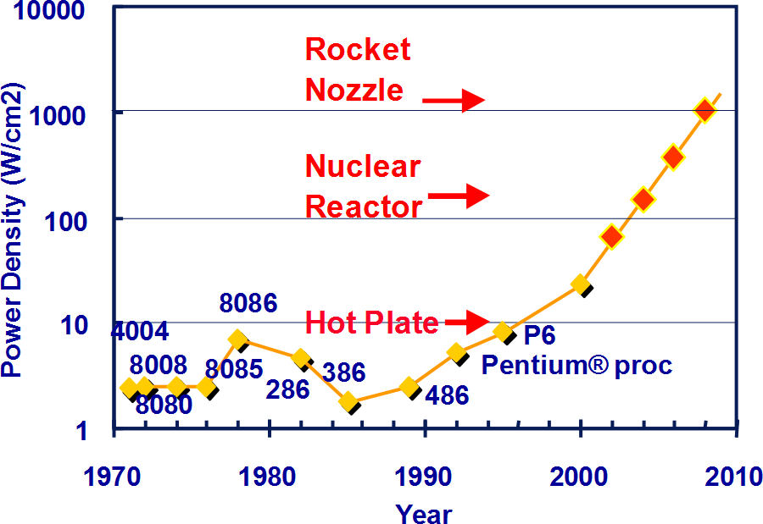
Power density too high to keep
junctions at low temp

Year | 1999 | 2002 | 2005 | 2008 | 2011 | 2014 | 2017
Feature size (nm) | 180 | 130 | 100 | 70 | 50 | 35 | 14
M trans/cm2 | 7 | 14-26 | 47 | 115 | 284 | 701 | 900
Chip size (mm2) | 170 | 170-214 | 235 | 269 | 308 | 354 | 460
Signal pins/chip | 768 | 1024 | 1024 | 1280 | 1408 | 1472 | ~1600
Clock rate (MHz) | 600 | 800 | 1100 | 1400 | 1800 | 2200 | 4200
Wiring levels | 6-7 | 7-8 | 8-9 | 9 | 9-10 | 10 | 10
Power supply (V) | 1.8 | 1.5 | 1.2 | 0.9 | 0.6 | 0.6 | 0.8

- Technology shrinks by ~0.7 per generation
- With every generation can integrate 2x more functions on a chip; chip cost
does not increase significantly
- Cost of a function decreases by 2x
- But …
  - How to design chips with more and more functions?
  - Design engineering population does not double every two years…
- Hence, a need for more efficient design methods
  - Exploit different levels of abstraction

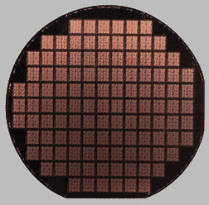

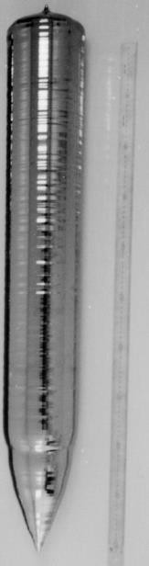
Silicon Cylinder
Silicon Wafer
Patterned Silicon Wafer

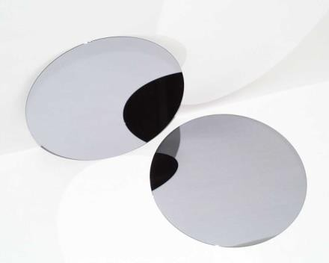
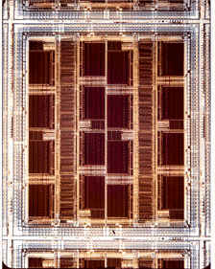Circuit Core

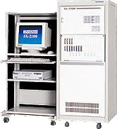
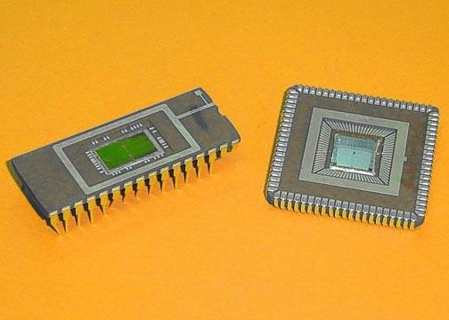
Unpackaged Die
Packaged Die Final Test

Die

Package
Circuit core

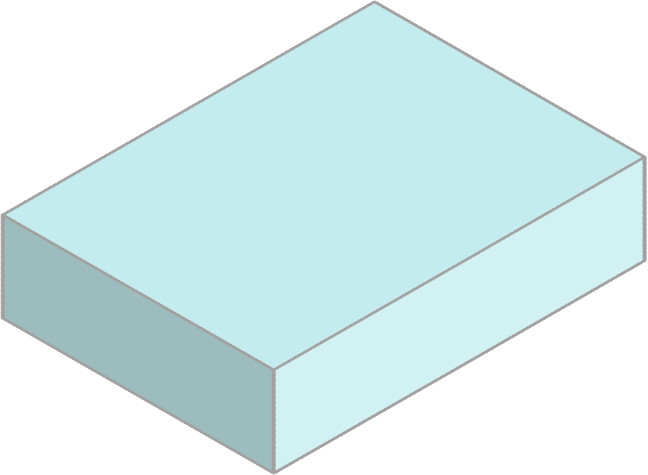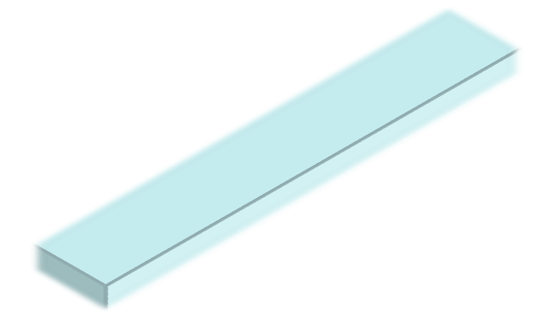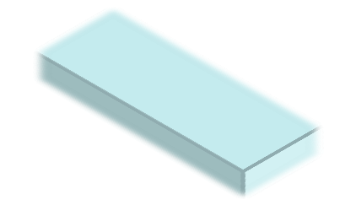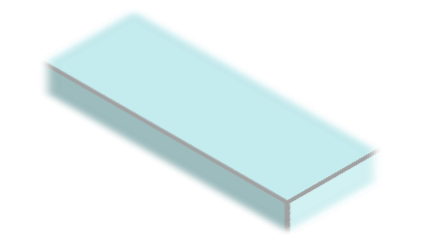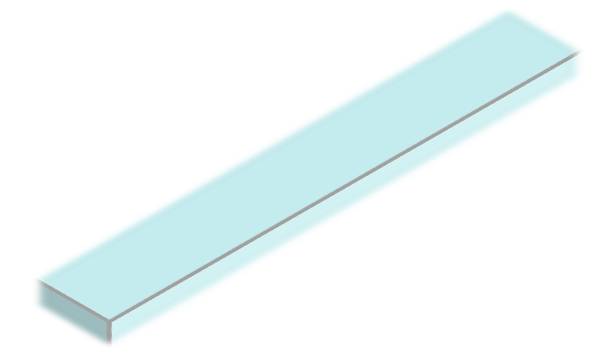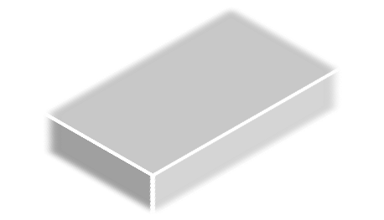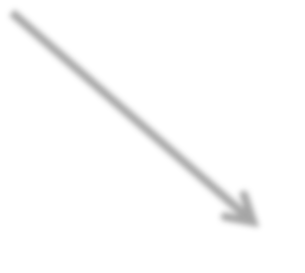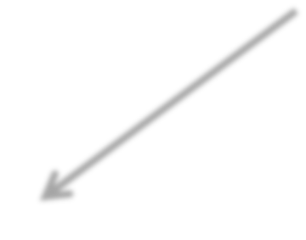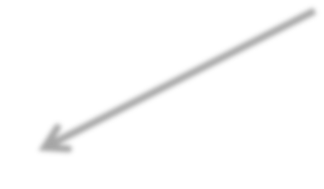Cavity
Packaged Die
Bond wire
Trace

PAD
Patterned Silicon
Wafer

Lead

Circuit Core

- Course Outline
- Introduction to ASIC/FPGA IC Design
  - Integrated Circuits (IC) History
  - Digital Design vs. Analog Design
  - ASIC vs. FPGA
  - Design Abstraction and Metrics
  - CMOS as the building block of Digital ASICs
  - Layout
  - Packaging

- Transmitter:
Analog/RF
Voice
Power
Amplifier
Modulator

- Receiver:
High-frequency carrier

Low-Noise
Amplifier
Audio
Amplifier
Demodulator
Down Converter

Analog/RF

Transmitter:

Digital (Baseband) Analog/RF Front-end

Voice
Modulator
Pulse shaping
Coding Interleaving
Voice Compression
ADC

- Receiver: This Course
Power Amplifier

Down Converter
ADC
Demodulator
Equalizer

Low-Noise
Amplifier
DAC
Voice Decompression
De-interleaving Decoding

Audio

Amplifier
Digital (Baseband)

Digital Design Advantages:

➢More noise reliability
➢Allows signal decoding and amplification
➢Allows coding to achieve higher performance
➢Allows encryption for higher security
➢Provides a perfect vehicle for digital signal processing
➢Allows modular chip design
➢Enjoys the benefit of advanced sophisticated CAD tools
➢Can be verified on programmable devices before tape-out
➢Provides a platform to merge multiple networks such as telephone, terrestrial TV and computer networks.

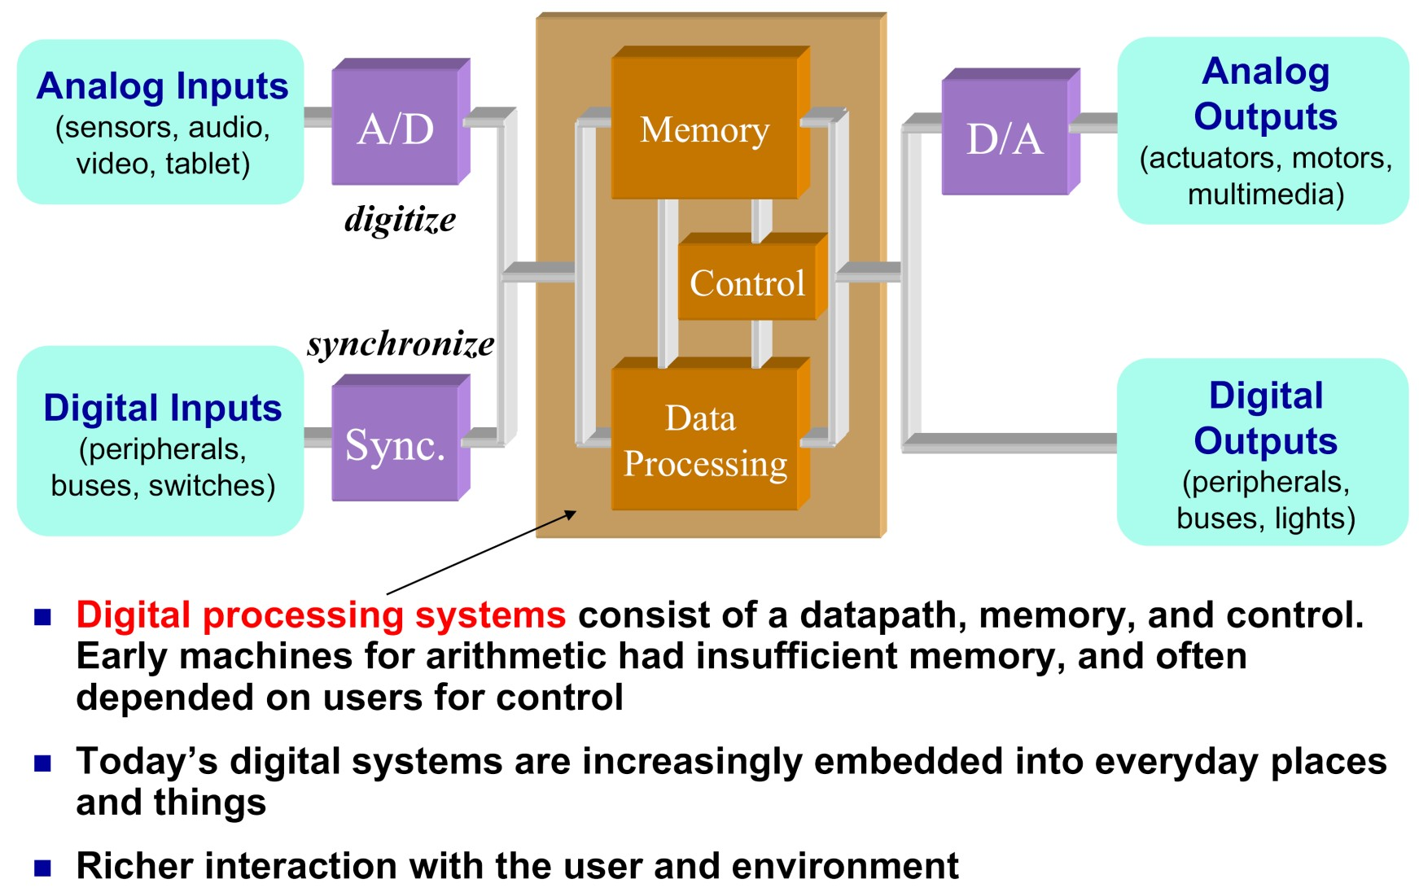

- Specific application (e.g., Digital Image Processor)
➢As opposed to a general microprocessor
- Design requirements
➢Images to be processed per second
➢Required processing
➢Interfacing
➢Dimension, power, price,…
- General design and simulation
- RTL level design to verify and simulate the design

- Higher levels: Few complicated blocks
- Lower levels: Many simple blocks

- To avoid any problem in lower levels, many simulations in higher levels

RTL

IC Fabrication
Idea

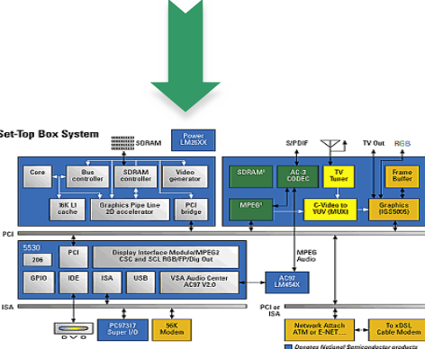
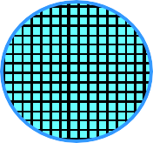
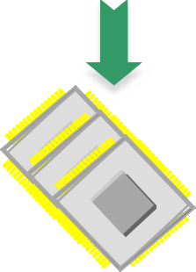
Architecture Design
Wafer (hundreds of dies)
Sawing & Packaging

Block diagram
Final chips

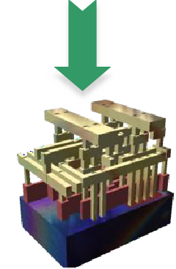
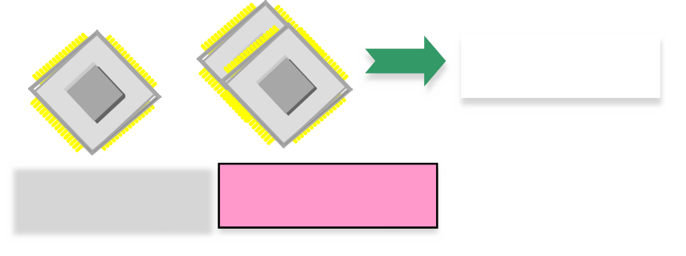Circuit & Layout Design
Testing
Good chips
Bad chips
customers


Layout

  - Printed Circuit Board (PCB)
  - Embedded Software
    - Microprocessor (general Purpose)
    - Microcontroller
    - Digital Signal Processor (DSP)
  - Programmable Logic Devices
    - Simple Programmable Logic Device (SPLD)
    - Complex Programmable Logic Device (CPLD)
    - Field Programmable Gate Arrays (FPGAs)
  - Application Specific Integrated Circuits (ASICs)

DSPs

- Easy to program (usually standard C)
- Very efficient for complex sequential math-intensive tasks
- Fixed datapath-width. Ex: 24-bit adder, is not efficient for 5-bit addition
- Limited resources

Microprocessors/Microcontrollers

- Lessens the risk of system development by reducing design complexity
- Fixed hardware so more effort on developing a good code
- Fixed HW not suitable for high level of parallelism/computations
- Many sequential nature
- One order of magnitude less performance than to-date FPGA/ASICs

Gate Array
Standard cell
PAL
PLA
Full-Custom
Semi-Custom
FPGA
CPLD
SPLD
ASIC
PLDs
Digital IC
This course

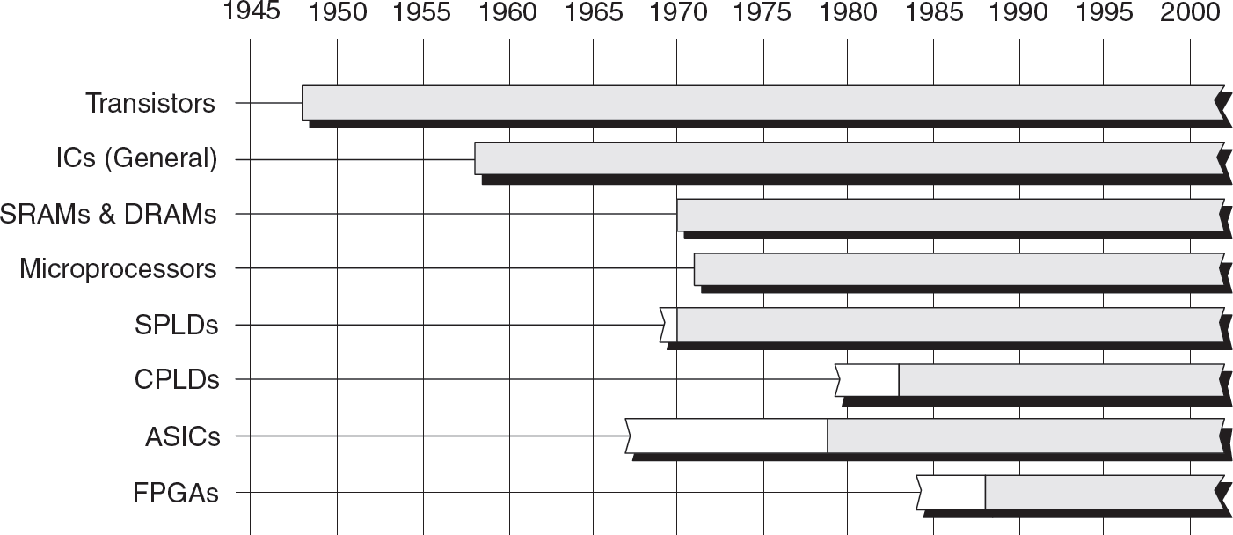

The white portions of the timeline bars indicate that although early incarnations of these technologies may have been available, they weren’t enthusiastically received by the engineers working in the
trenches during this period. For example, although Xilinx introduced the world’s first FPGA as early as 1984, design engineers didn’t really start using it until the early 1990s.

Course Outline

Course Outline
- Introduction to ASIC/FPGA IC Design
  - Integrated Circuits (IC) History
  - Digital Design vs. Analog Design
  - ASIC vs. FPGA
  - Design Abstraction and Metrics
  - CMOS as the building block of Digital ASICs
  - Layout
  - Packaging

- Field Programmable Gate Array (FPGA) Advantages:
➢Fast programming and testing time by the end user (instant turn-around)
➢Excellent for prototyping
  - Easy to migrate from prototype to the final design
➢Can be re-used for other designs
➢Cheaper (in small volumes) lower start-up costs
➢Re-programmable
➢Lower financial risk
➢Ease of design changes/modifications
➢Cheaper design tools

- FPGA Drawbacks:
➢Slower than ASIC (2-3 times slower)
➢Power hungry (up to 10 times more dynamic power)
➢Use more transistors per logic function
➢More area (20 to 35 times more area than a standard cell ASIC)

- Application Specific Integrated Circuit (ASIC) Advantages:
➢Faster
➢Lower power
➢Cheaper (if manufactured in large volumes)
➢Use less transistors per logic function

- ASIC Drawbacks:
➢Implements a particular design (not programmable)
➢Takes several months to fabricate (long turn-around)
➢More expensive design tools
➢Very expensive engineering/mask cost for the first successful design

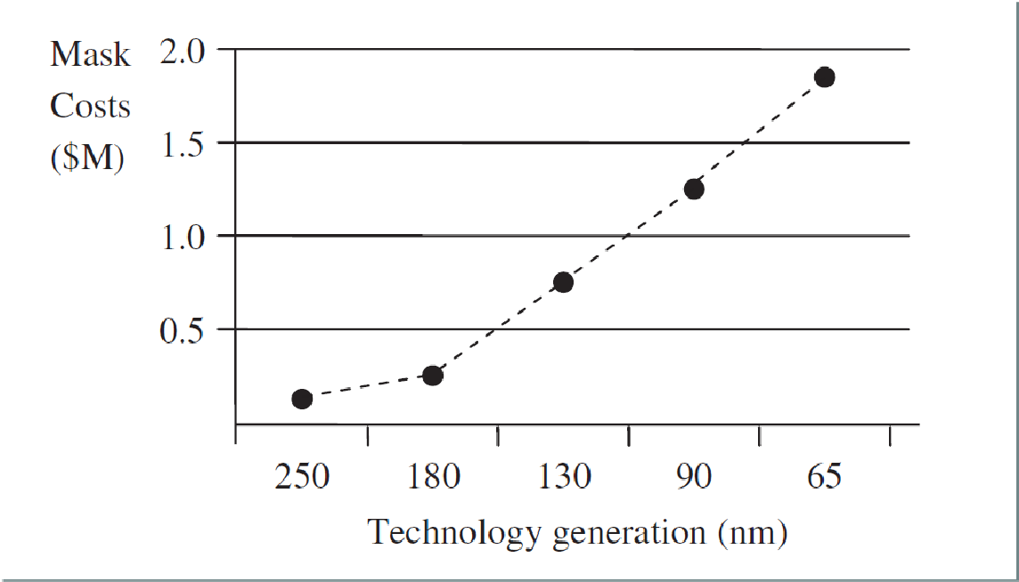

- The ASIC is accompanied by increasing nonrecurrent engineering (NRE) costs which meant
that there was an increased emphasis on “right first time” design.

- These NRE costs is largely due to the cost of generating masks as it is becoming more expensive to generate the masks for finer geometries needed by shrinking silicon technology dimensions.

- Expensive & time consuming
fabrication in semiconductor foundry
- Designed all the way from
behavioral description to
physical layout
ASIC
Application Specific Integrated Circuit
- Bought off the shelf & reconfigured
by the end designers
- No physical layout design
- Design ends with a bitstream used
to configure a device
FPGA
Field Programmable Gate Array

ASICs FPGAs
Off-the-shelf
High performance
Low development cost
Low power
Short time to market
Low cost in
high volumes
Re-configurability

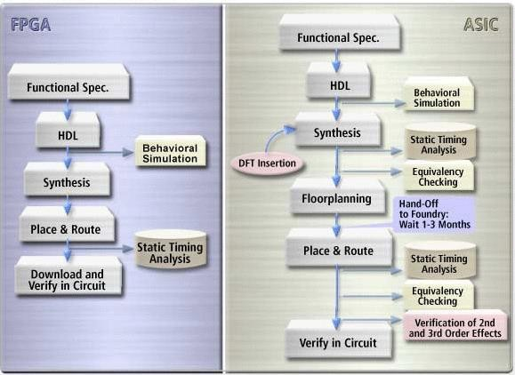

Course Outline

Course Outline
- Introduction to ASIC/FPGA IC Design
  - Integrated Circuits (IC) History
  - Digital Design vs. Analog Design
  - ASIC vs. FPGA
  - Design Abstraction and Metrics
  - CMOS as the building block of Digital ASICs
  - Layout
  - Packaging

  - Divide-and-Conquer
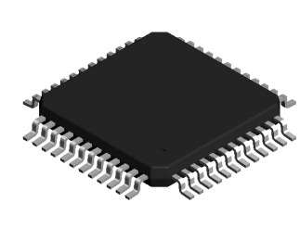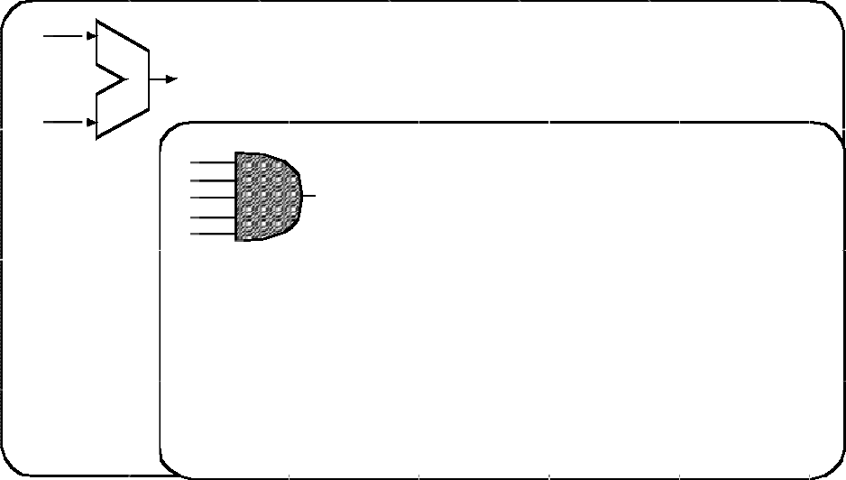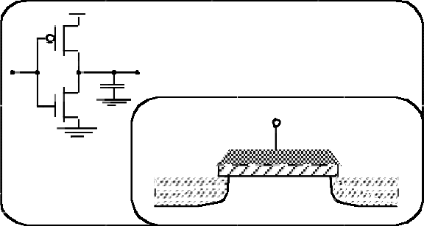➢Design modules once
SYSTEM
MODULE
+
GATE
CIRCUIT
S
n+
DEVICE
G
D
n+
➢Instantiate them thereafter
➢Standard Cells
- Already laid out
➢Avoid re-design
➢Same as programming

- Designer cares about module’s:
➢Functionality
➢Delay characteristics
➢Area
- NOT:
➢How the module was designed
➢Detailed solid-state behavior

This Course

VLSI Course

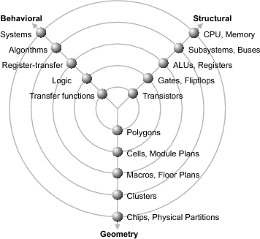Y-Chart

Circuit Logic
Register Transfer Algorithmic
Architectural (System)
System Level
Algorithmic Level

I/O
Processor
RAM
ROM
A:=A*B+F IF(C=TRUE) THEN A:=A+2*F
ELSE A:=A-1 ENDIF

Register Transfer Level Logic Level
MUX

ROM
A
L
U
C
Q
D Qn
|
&
Register

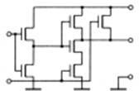Circuit Level

Performance Metrics of a Digital Chip:
  - Cost
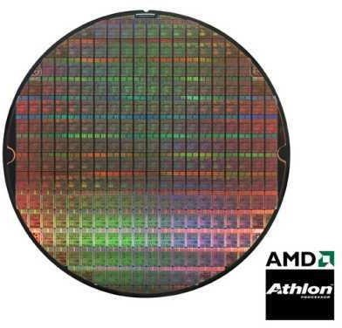➢NRE (fixed) costs - design effort
Single Die
Wafer
Diameter: 10-30 cm
Thickness: 1 mm
➢RE (variable) costs - cost of parts, assembly, test
  - Speed
➢Delay (ns) → Operating Frequency (MHz)
  - Power Dissipation
  - Energy to Perform a Function
➢Energy per bit (nJ/b)
  - Reliability
➢Noise immunity
➢Noise margin
  - Scalability
➢Larger Designs
  - Time-to-Market

Performance Metrics of a Digital Chip:
  - Cost
➢NRE (fixed) costs - design effort
Single Die
Wafer
➢RE (variable) costs - cost of parts, assembly, test
  - Speed
➢Delay (ns) → Operating Frequency (MHz)
  - Power Dissipation
  - Energy to Perform a Function
➢Energy per bit (nJ/b)
  - Reliability
➢Noise immunity
➢Noise margin
  - Scalability
➢Larger Designs
  - Time-to-Market

NRE (non-recurring engineering) costs
  - Fixed cost to produce the design
    - Design effort
    - Design verification effort
    - Mask generation
  - Influenced by the design complexity and designer productivity
  - More pronounced for small volume products
- RE (Recurring costs) – proportional to the product volume (i.e., Variable)
  - Silicon processing
    - also proportional to chip area
  - Assembly (packaging)
  - Test
fixed cost
Cost per IC = variable cost per IC + -----------------
volume

cost of die + cost of die test + cost of packaging variable cost = ----------------------------------------------------------------
final test yield

cost of die
cost of wafer
= -----------------------------------
dies per wafer × die yield

π × (wafer diameter/2)2 π × wafer diameter Dies per wafer = ---------------------------------- − ---------------------------
die area √ 2 × die area

α depends on the complexity of the manufacturing process (roughly proportional to the number of masks)
die yield = (1 + (defects per unit area × die area)/α)-α

Example
  - Wafer size of 12 inches, die size of 2.5 cm2, 1 defects/cm2,
    - α = 3 (measure of manufacturing process complexity)
  - 252 dies/wafer (remember, wafers round & dies square)
  - Die yield of 16%
  - 252 x 16% = only 40 dies/wafer die yield !

Die cost is a strong function of the die area
  - Proportional to the third or fourth power of the die area

Cost of die = f(die area)4

Chip | Metal layers | Line width | Wafer cost | Defects  /cm2 | Area (mm2) | Dies  /wafer | Yield | Die cost
386DX | 2 | 0.90 | $900 | 1.0 | 43 | 360 | 71% | $4
486DX2 | 3 | 0.80 | $1200 | 1.0 | 81 | 181 | 54% | $12
PowerPC 601 | 4 | 0.80 | $1700 | 1.3 | 121 | 115 | 28% | $53
HP PA 7100 | 3 | 0.80 | $1300 | 1.0 | 196 | 66 | 27% | $73
DEC Alpha | 3 | 0.70 | $1500 | 1.2 | 234 | 53 | 19% | $149
Super SPARC | 3 | 0.70 | $1700 | 1.6 | 256 | 48 | 13% | $272
Pentium | 3 | 0.80 | $1500 | 1.5 | 296 | 40 | 9% | $417

Performance Metrics of a Digital Chip:
- Cost
➢NRE (fixed) costs - design effort
Single Die
Wafer
➢RE (variable) costs - cost of parts, assembly, test
- Speed
➢Delay (ns) → Operating Frequency (MHz)
- Power Dissipation
- Energy to Perform a Function
➢Energy per bit (nJ/b)
- Reliability
➢Noise immunity
➢Noise margin
- Scalability
➢Larger Designs
- Time-to-Market

Frequency of operation: 1/T
  - Dependent on the propagation delay of signal through the logic
  - Time to get the data out/in of the registers
  - Clock uncertainty

tp is a typical measure (not an accurate one)
  - the delay experienced by a signal when passing through a gate
  - 50% transition points of the input and output waveforms
    - Two types LH and HL
    - Good for comparison

Rise time/fall time affects delay
  - 10% - 90% definitions


Vin Vout

input wavefor
Vin
m
50%
Propagation delay
tp = (tpHL + tpLH)/2
tpHL
tpLH
t
Vout
90%
t
rm
50%
signal slopes
10%
t
f
t
t
r

outpu
wavefo

© M. Shabany, ASIC & FPGA Chip Design

Performance Metrics of a Digital Chip:
- Cost
➢NRE (fixed) costs - design effort
Single Die
Wafer
➢RE (variable) costs - cost of parts, assembly, test
- Speed
➢Delay (ns) → Operating Frequency (MHz)
- Power Dissipation
- Energy to Perform a Function
➢Energy per bit (nJ/b)
- Reliability
➢Noise immunity
➢Noise margin
- Scalability
➢Larger Designs
- Time-to-Market

Peak transient power
Ppeak = ipeakVsupply = max[p(t)]
  - Power line sizing, decoupling, etc.

Average power
  - Battery current delivery, cooling system

Static power vs. Dynamic power
  - Static current ➔ no computation, etc
  - Dynamic current ➔ Switching on/off the gates
- The higher the number of switching events, the higher the dynamic power consumption
- Dynamic Energy ➔ Amount of energy that is needed to be spent to do a job
  - Time is no matter

Propagation delay and the power consumption of a gate are related
- Propagation delay is (mostly) determined by the speed at which a given amount of energy can be stored on the gate capacitors
  - the faster the energy transfer (higher power dissipation) the faster the gate

For a given technology and gate topology, the product of the power
consumption and the propagation delay is a constant
  - Power-delay product (PDP) – energy consumed by the gate per switching event

An ideal gate is the one that is fast and consumes little energy, so the ultimate quality metric is
  - Energy-delay product (EDP) = power-delay

Performance Metrics of a Digital Chip:
- Cost
➢NRE (fixed) costs - design effort
Single Die
Wafer
➢RE (variable) costs - cost of parts, assembly, test
- Speed
➢Delay (ns) → Operating Frequency (MHz)
- Power Dissipation
- Energy to Perform a Function
➢Energy per bit (nJ/b)
- Reliability
➢Noise immunity
➢Noise margin
- Scalability
➢Larger Designs
- Time-to-Market

- Noise : unwanted variations of voltages and currents at the logic nodes

from two wires placed side by side
    - Capacitive coupling
      - Voltage change on one wire can
influence signal on the neighboring wire
      - Cross talk
    - Inductive coupling
      - Current change on one wire can influence signal on the neighboring wire

from noise on the power and ground supply rails
    - May influence signal levels in the gate

v(t)

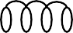 i(t)

VDD

Noise Margins
- For robust circuits, want the “0” and “1” intervals to be as large as possible
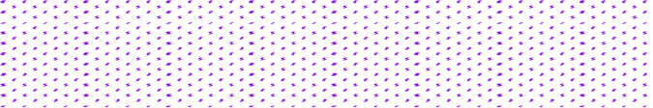VDD VDD
NMH = VOH - VIH

VOH

Noise Margin High

Noise Margin Low
"1"

VIH
Undefined
Region
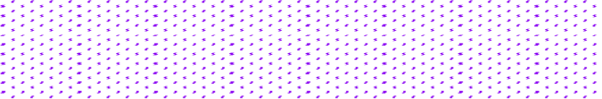VIL
NML = VIL - VOL

VOL

Gnd

"0"
Gnd

Gate Output Gate Input
Noise margin represents the levels of noise that can be sustained
when gates are cascaded

Noise Immunity
  - Noise margin expresses the ability of a circuit to overpower a noise source
    - Noise sources: supply noise, cross talk, interference, offset
  - Absolute noise margin values are deceptive
    - Floating node is more easily disturbed than a node driven by a low
impedance (in terms of voltage)

  - Noise immunity expresses the ability of the system to process and transmit information correctly in the presence of noise (noise rejection)

  - For good noise immunity, the signal swing (i.e., the difference between VOH and VOL) and the noise margin have to be large enough to overpower the impact of fixed sources of noise

Course Outline

Course Outline
- Introduction to ASIC/FPGA IC Design
  - Integrated Circuits (IC) History
  - Digital Design vs. Analog Design
  - ASIC vs. FPGA
  - Design Abstraction and Metrics
  - CMOS as the building block of Digital ASICs
  - Layout
  - Packaging

Bipolar Junction Transistor (BJT)
  - Small current in Base drives a larger current b/w Emitter & Collector.

Mostly Analog

❑

Mostly Digital
➢Quiescent power dissipation due to the Base current
➢High power dissipation limits the number of transistors on a single chip
➢Not suitable for Very Large Scale Integration (VLSI)

Metal Oxide Semiconductor Field Effect Transistors (MOSFET)
- Come with almost zero control current (Gate voltage controls the drain current)
➢Higher integration
➢Much lower power consumption than BJT
➢Come in two flavors : n-MOS (n-type dopants), p-MOS (p-type dopants)

- Complementary Metal Oxide Semiconductor (CMOS)
➢Utilizing both n-MOS and p-MOS transistors

  - Transistors are built on a silicon substrate
  - Silicon is a Group IV material → covalent bonds with 4 adjacent atoms
  - Silicon is a poor conductor → can be raised by adding dopants

Si Si Si

n-type
- Group V dopants
- Five valence electrons
- Extra electron free to move
- Negative carrier
- Example:
➢Arsenic, Phosphorus

Si

Si

Si Si

Si Si
  - ype

Si Si - Si
- Group III dopants
- 3 valence electrons
- Missing electron(hole) free to move
- Positive carrier
- Example:
➢Boron
Si Si Si
+

Si As+ Si Si B ⁻ Si

Si Si Si Si Si Si

  - Four terminals:
    - Gate
    - Source
    - Drain
    - Body

Body

Source

Gate

Drain

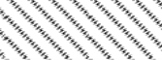Polysilicon SiO 2
G
n+

  - Consists of :
    - Gate (Metal (old), Polysilicon (now))
    - Insulating layer (SiO2 (oxide- glass))
    - Source (n+ in nMOS, p+ in pMOS)
    - Drain (n+ in nMOS, p+ in pMOS)
    - Body (conductor)
    - n+: Heavily doped n-type
    - P+: Heavily doped p-type
D S
B
bulk Si
p
n+

nMOS

  - Gate–oxide–body stack looks like a capacitor

  - Body is commonly tied to ground (0 V)

  - Gate at low voltage:
    - Body is at low voltage
    - Source-body diode is OFF
    - Drain-body diode is OFF
    - No current flows
    - Transistor is OFF

Body

Source

Gate

Drain

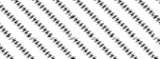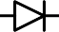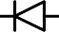OFF
bulk Si
p
n+
n+

- Gate at high voltage:
  - Positive charge on gate
  - Negative charge attracted to body
  - Inverts a channel under gate to n-type
  - Current flow in this channel b/w source and drain when drain voltage is nonzero
  - Transistor is ON

Body
Source
Gate
Drain

ON
bulk Si
p
n+
n+


- Similar to nMOS with reversed doping and voltages
- Body is commonly tied to high voltage (VDD)
- Gate low: transistor ON
- Gate high: transistor OFF
- Bubble indicates inverted behavior

Body
Source
Gate
Drain

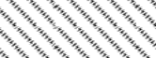Polysilicon SiO 2

G
p+
p+

D S
bulk Si
p
B
pMOS

- L is the channel length
- L : Process parameter, technology
- Smaller L → Faster transistors → higher speed circuits
- Typical process values: 0.35μm, 0.18μm, 0.13μm, 90nm, 60nm, …
- VDD decreases by technology
  - 1.5 V for 0.18 μm
  - 1.2 V for 0.13 μm
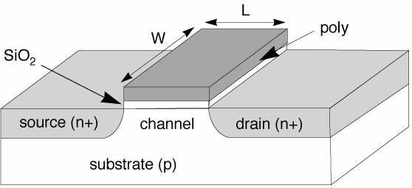
- Lower VDD saves power consumption
- GND = 0 V

  - Silicon wafer is the base material
    - Diameter: 10-30 cm
    - Thickness: 1 mm

  - CMOS : both nMOS and pMOS transistors fabricated on a single wafer
  - Wells : special regions to separate bulks of nMOS and pMOS

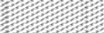SiO₂

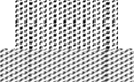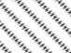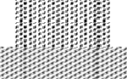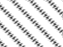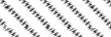n+ diffusion p+ diffusion polysilicon metal1
p substrate
n well
p+
p+
n+
n+
nMOS transistor pMOS transistor

  - Substrate must be tied to GND and n-well to VDD
  - Poor connection of metal to lightly-doped semiconductor (Shottky Diode)
  - 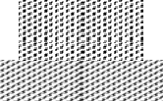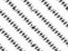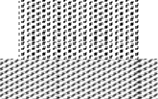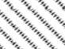Use heavily doped well and substrate contacts
GND
V DD
well tap
p substrate
substrate tap
n well
n+
p+
p+
n+
n+
p+
Cross Section along Dashed Line
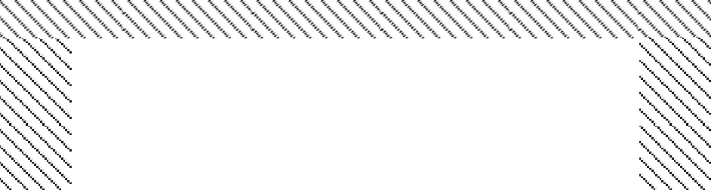
Top View
VDD
GND
A

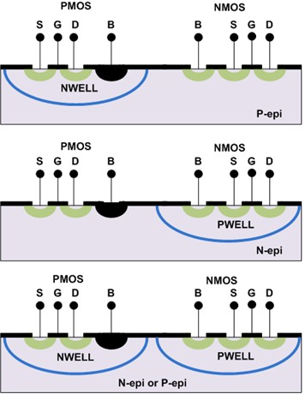
•ارزان
•اتصال subبه زمین مشترک
NWELL
PWELL
•دو درجه آزادی
•ایزوله از sub
Twin-WELL
ارزان
اتصال subبه بزرگترین منبع
گران

Course Outline

Course Outline
- Introduction to ASIC/FPGA IC Design
  - Integrated Circuits (IC) History
  - Digital Design vs. Analog Design
  - ASIC vs. FPGA
  - Design Abstraction and Metrics
  - CMOS as the building block of Digital ASICs
  - Layout
  - Packaging

  - Chips are specified with set of masks
  - Minimum dimensions of masks determine transistor size (and hence

speed, cost, and power)
  - “Feature size”
Lmin= distance between source and drain (channel)
(minimum width of Polysilicon)

  - Feature size improves 30% every 3 years or so
SiO₂ gate oxide
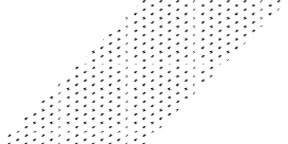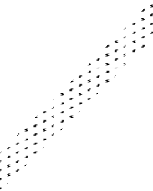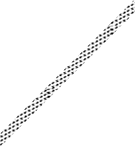
polysilicon
gate
W
tox
n+
L
n+
p-type body
Feature Size

  - Can integrate 2× more functions per chip → 2× less cost per function

  - Normalize for feature size when describing design rules (λ
= Lmin
/ 2 )

    - E.g., λ = 90nm in 0.18 μm process

  - Each layout consists of various levels described by different colors.

Top View

Cross Section View
P substrate
wafer

n well

  - Circuit engineer designs a circuit
  - Process engineer fabricates the design
Deign Rule Check (DRC)
is the interface between them

  - DRC : constraints on patterns in terms of minimum width and separation
  - DRC: guarantees that the circuit to be manufacturable
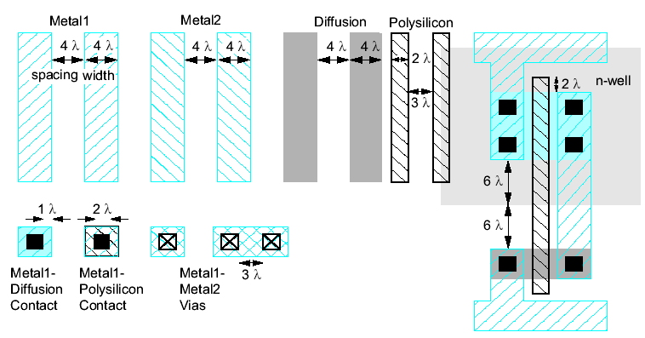

  - 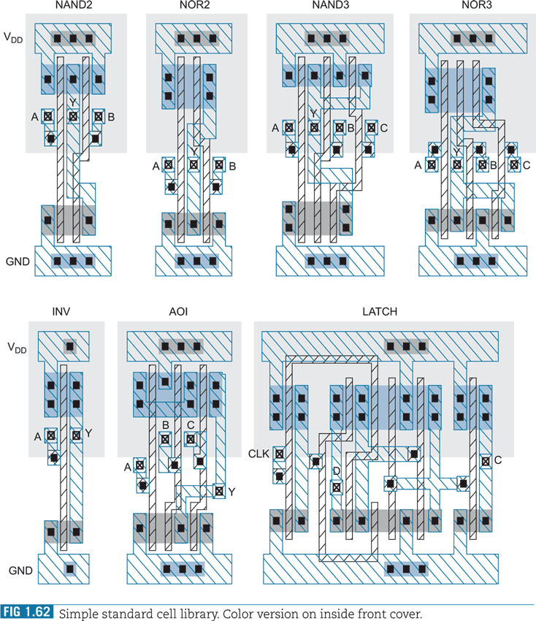Designed and laid-out standard cells
  - They are placed & abutted in a chip

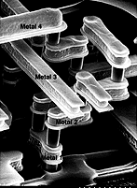Metal 2

Via 12

Metal 1

Several metal layers used for routing

  - Standard cells are automatically placed and routed using different metal
layers through the corresponding CAD tools
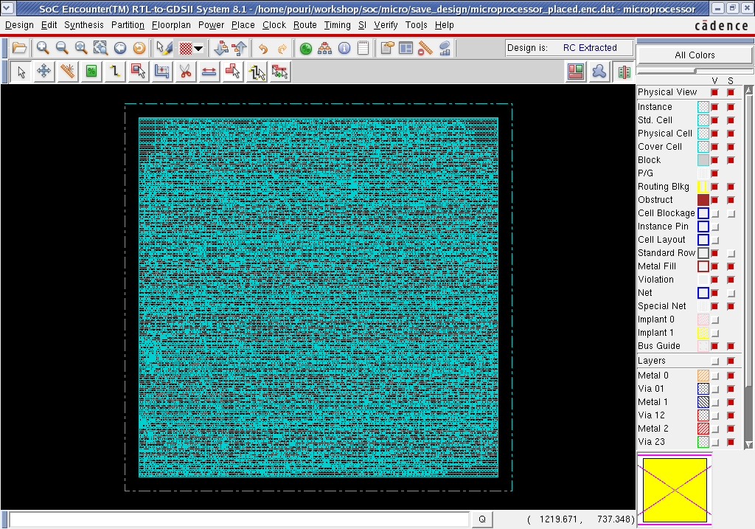

  - Start with the pin count (# of I/O and VDD, VSS pads)
  - 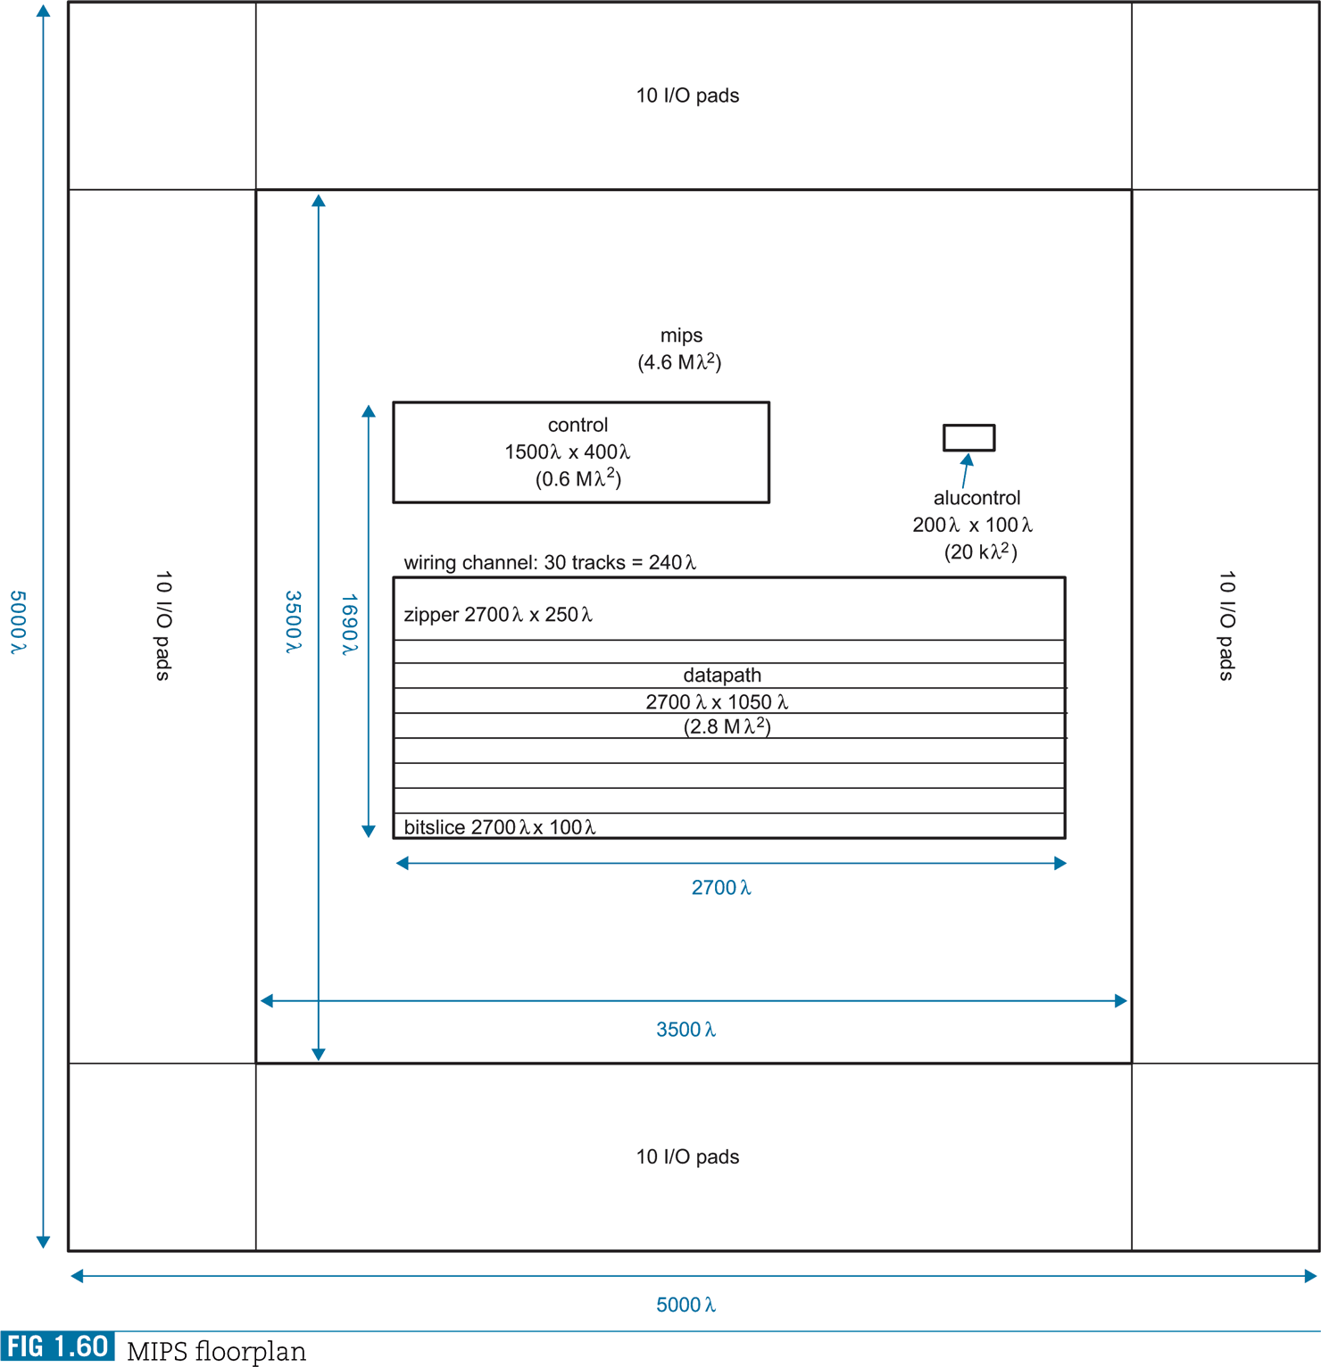Pads are already designed (provided in the design kit)

VDD Core
I/O Pads
I/O Pads

Corner Pads

Corner Pads
I/O Pads
VSS Core

Core
Design

Corner Pads
I/O Pads
Corner Pads

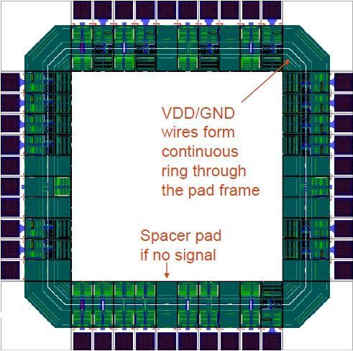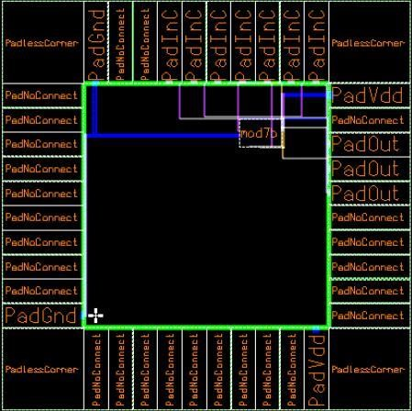

Layout View Design View

Course Outline

Course Outline
- Introduction to ASIC/FPGA IC Design
  - Integrated Circuits (IC) History
  - Digital Design vs. Analog Design
  - ASIC vs. FPGA
  - Design Abstraction and Metrics
  - CMOS as the building block of Digital ASICs
  - Layout
  - Packaging

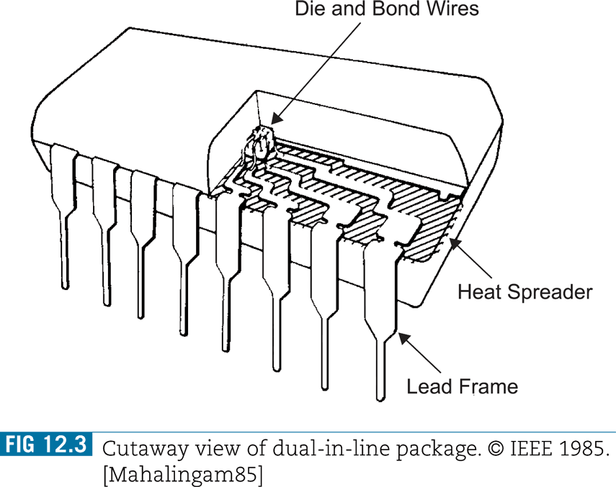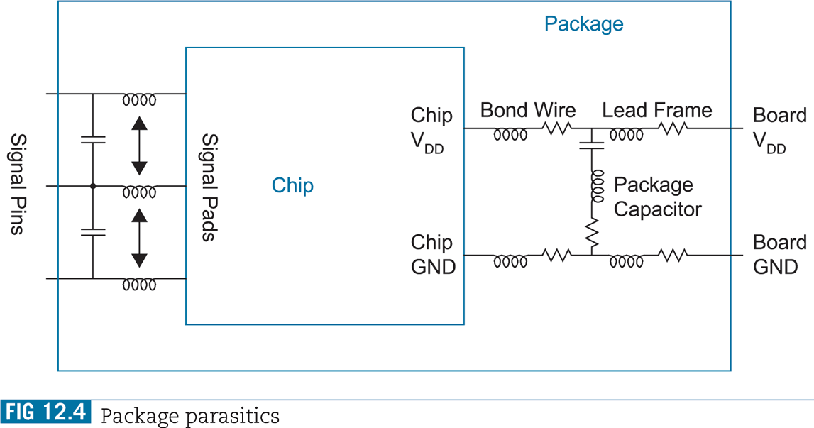

Package:
    - Die interface to outside world
- Removes heat from chip
- Mechanical support
- Protects die against humidity
× Introduces delay/parasitics to the chip

Advanced Package Requirements:
    - Electrical: Low Parasitics
    - Mechanical: Reliable and Robust
    - Thermal: Efficient Heat Removal
    - Economical: Cheap

Pad Pitch

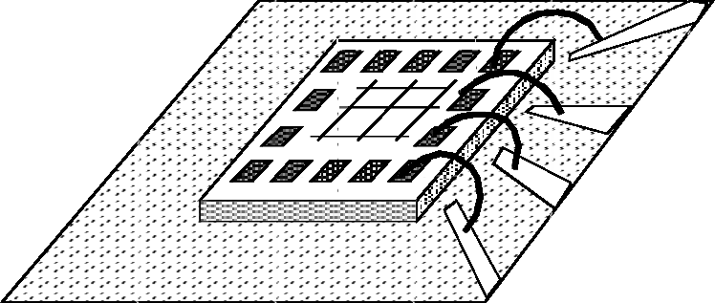Die
Substrate
Die

Pad
Lead Frame

Solder bumps

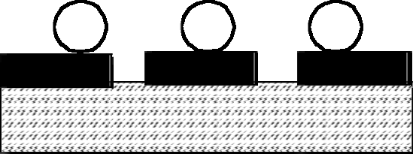Interconnect Layers

Substrate

Wire Bonding
- Small pin count
- Must be attached serially
- Large inductance
- Cross talk b/w wires
- Pads on four sides of the chip
Flip-Chip Bonding
- Large pin count
- Connections made simultaneously
- Superior electrical performance
- Small cross talk
- Pads at any position on the chip

Package-Socket-PCB interconnection:
- 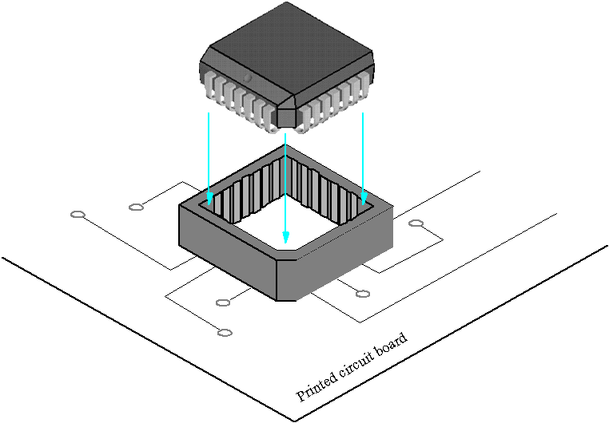Performance bottlenecks:

Chip itself
  - Package
  - Socket
  - Board

Package

Socket

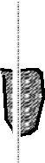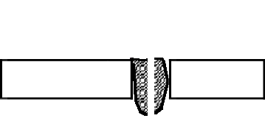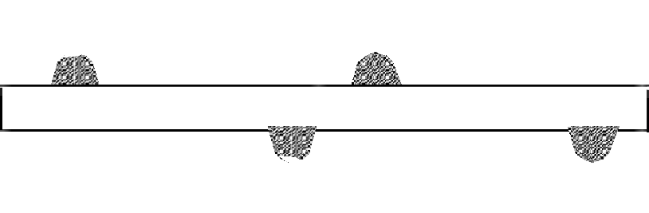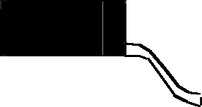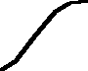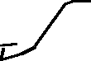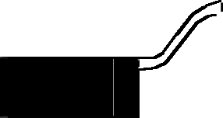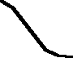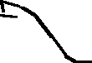

Through-Hole Mounting
- Mechanically reliable
× Low package density
× Limits routing on the board
- Dualin-Line (DIP) (up to 64 pins)
- PGA (up to 400 pins)

Surface Mount
- More wiring space
- Higher package density
- Chips at both sides of the board
× Weak chip-board connection
× Non-accessible pins for testing

For very large pin-counts, even surface-mount packaging is not enough!
  - Ball Grid Array (BGA)
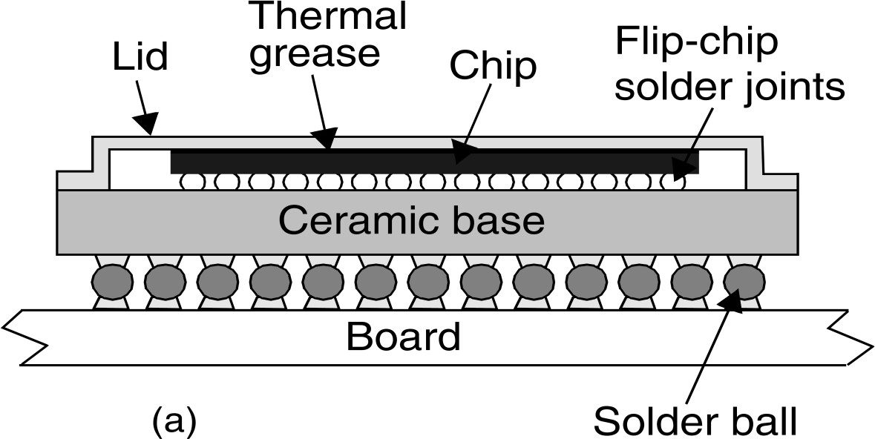

Solder bumps are used to connect both the die to the package substrate and the package to the board

Package Material:
  - Plastics (cheaper)
  - Ceramic (Better heat removal)

Package Types:
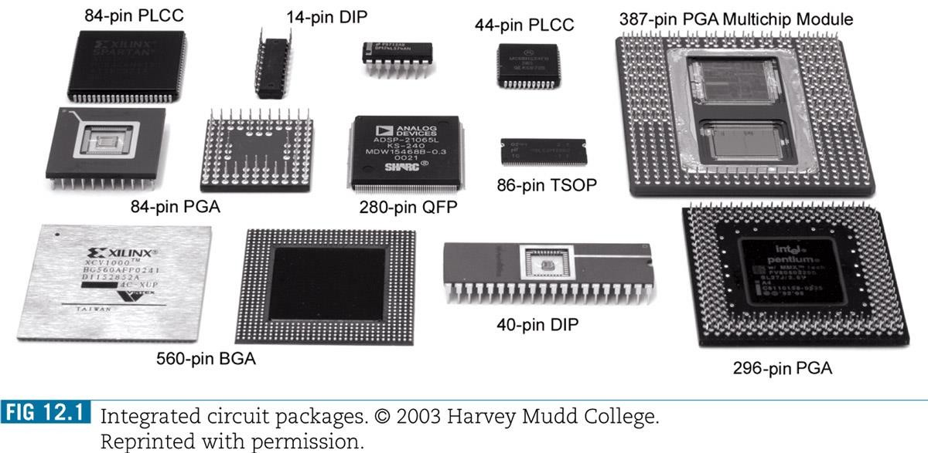

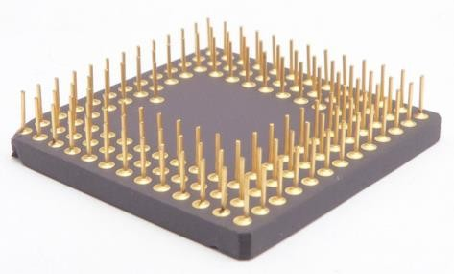

Pin Grid Array (PGA)
Quad Flat Pack (QFP)

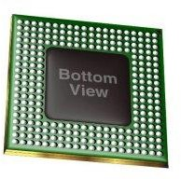
Die

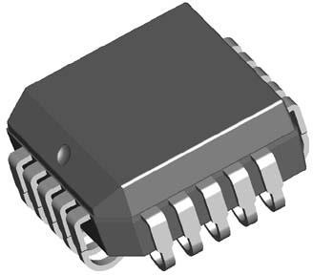
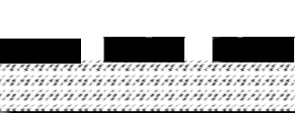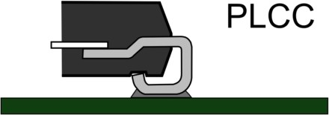Solder bumps
Interconnect Layers

Substrate

Ball Grid Array (BGA) Plastic Leader Chip Carrier
(PLCC)

